**ENGR 122 Homework 8**

**NOTE:** INDIVIDUALS: Use engineering format for problems 1-3. Each student should turn in problems 1 through 3 in their own homework.

TEAMS: Complete problems 4 through 6 as a team and turn in one paper for each team in a separate stack at the front of the room. Use non-engineering format for these problems. Write the names of all team members on the paper that you turn in for the team.

1. A battery supplies a DC electric motor with 6V and 1A. The motor is attached to a gearbox and pulley system that lifts a 20 oz. weight at a rate of 1-inch per second. Determine the efficiency of the system. Complete your solution using Mathcad. 2.354%

**Given:** W = 20 oz

v = 1 in/s

V = 6V

I = 1A

v = h / s

**Request:** percent efficiency ɲ

**Solution:**

1 in = 0.0254 m

20 oz = 5.5607702 N











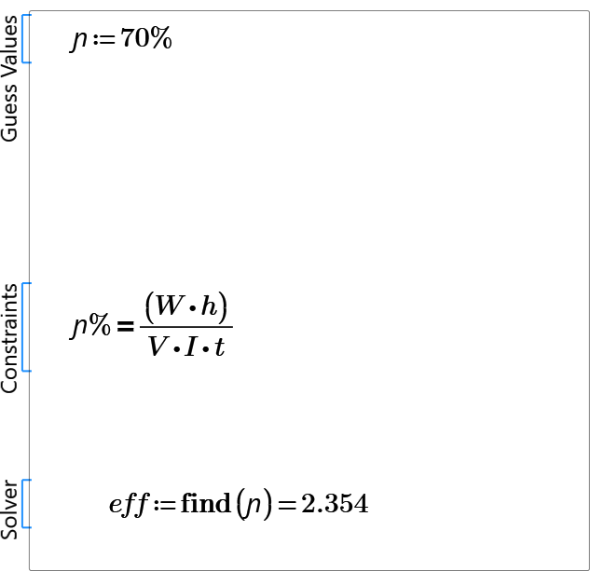

1. Consider the gear train shown below. If the DC motor is running at 5000 RPM and can supply a maximum 0.063 in-lbf of torque, assuming 100% efficiency, determine:
   1. The maximum weight W that the pulley can lift.1.3lbf
   2. The velocity of the string. 25.39in/s

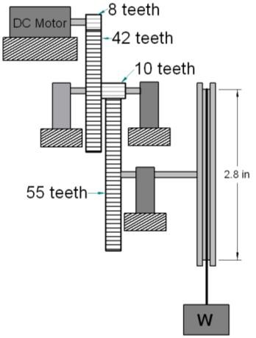

1. In the gear train shown, gear 1 has 14 teeth, gear 2 has 43 teeth, gear 3 has 22 teeth, and gear 4 has 92 teeth. A rope carrying a weight of W = 300lb is being wound at a constant rate onto a spool with a radius of r = 1 ft. The spool is directly attached to gear 4. Gears 2 and 3 are rigidly connected to each other. Assuming 100% efficient gears, what is the torque supplied by the output shaft of the motor? 23.36 ft-lbf

*Hint: Remember, you can relate torque through the gear train using the gear ratios discussed in class 6. You can also calculate torque by as Force x Distance. This expression may give you a starting point.*

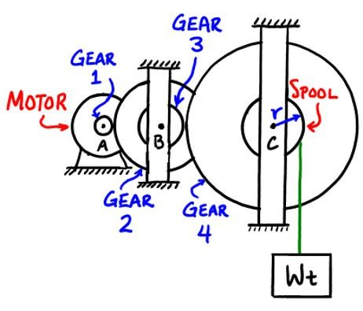

The group assignment for this homework was turned in by another member.